

Name : Y.Manoj kumar Course name : 5Gand6G Communicaton Registration num:1912260567 Course code : ECA5610
Experiment Number: 2
Aim : To model a simplified hexagonal cellular network and study how cell radius affects coverage, estimated user capacity and handoff as a mobile crosses a cell boundary.
Objectives
By the end of the experiment, students should be able to : 1. Model adjacent hexagonal cell coverage and identify cell centers and boundaries.
2. Estimate the number of cells required to cover a fixed service area for different cell radii. 3. Compare estimated users served under an explicit per-cell capacity assumption. 4. Simulate a mobile moving across a cell boundary and identify the serving-cell transition.
Requirements • Computer with MATLAB R2019b or later. • No RF hardware is required; this is a geometric and analytical simulation.

Theoretical Background A regular hexagonal cell is an idealized coverage region. For cell radius R, measured from the center to a vertex, its area is A_cell = (3√3/2)R². A first-order estimate for a service area A is N_cells = ceil(A/A_cell). This area ratio ignores boundary overlap, roads, terrain, irregular coverage and the fact that real cell layouts extend beyond the service boundary.
For a simple capacity comparison, assume each cell can serve C users at the same time. Estimated network capacity is N_cells × C. This is a planning illustration, not a prediction of a real network; capacity also depends on spectrum, scheduling, traffic, interference, backhaul and radio conditions.
For handoff, the serving cell is approximated as the cell center nearest to the mobile. A handoff is indicated when the nearest-center identity changes. Real systems use measured radio quality, hysteresis, time-to-trigger, load and network policy, so this geometric rule is only a teaching model.

Procedure
1. Run the MATLAB script below and record the cell area, estimated cell count and total illustrative capacity for each radius.
2. Inspect the hexagonal layout and confirm that adjacent cells share edges without gaps in the idealized tiling.
3. Inspect the mobile-path plot and note the simulated handoff point.
4. Change the service area, radii or users-per-cell assumption one at a time; rerun and compare results.
5. Explain why the geometric cell count and nearest-center handoff differ from an nal cellular network.

MATLAB Program — Coverage, Cell Splitting and Handoff

% Experiment 2: simplified hexagonal coverage and handoff
clear; clc; close all;

% Baseline assumptions
serviceAreaKm2 = 5;
radiiKm = [1.0 0.5];
usersPerCell = 30;
hexArea = @(R) (3*sqrt(3)/2) .* R.^2;

cellAreaKm2 = hexArea(radiiKm);
cellCount = ceil(serviceAreaKm2 ./ cellAreaKm2);
estimatedUsers = cellCount .* usersPerCell;
capacityTable = table(radiiKm(:), cellAreaKm2(:), cellCount(:), ...
repmat(usersPerCell,numel(radiiKm),1), estimatedUsers(:), ...
'VariableNames', {'Radius_km','CellArea_km2','EstimatedCells', ...
'UsersPerCell','IllustrativeUsers'});
disp(capacityTable);

% Plot a 7-cell cluster: central cell plus six neighbors
R = radiiKm(1);
centers = [0 0; 1.5*R sqrt(3)*R/2; 1.5*R -sqrt(3)*R/2; ...
0 sqrt(3)*R; 0 -sqrt(3)*R; -1.5*R sqrt(3)*R/2; ...
-1.5*R -sqrt(3)*R/2];
theta = (0:6)*pi/3; % flat-top hexagon vertices
figure; hold on; axis equal; grid on;
for k = 1:size(centers,1)
plot(centers(k,1)+R*cos(theta), centers(k,2)+R*sin(theta), 'k-');
text(centers(k,1),centers(k,2),sprintf('Cell %d',k), ...
'HorizontalAlignment','center');
end
xlabel('x (km)'); ylabel('y (km)');
title('Idealized Seven-Cell Hexagonal Cluster');
hold off;

% Mobile moves across the boundary between centers at x=0 and x=1.5R
mobileX = linspace(-0.2*R,1.7*R,300);
mobileY = zeros(size(mobileX));
d1 = hypot(mobileX, mobileY);
d2 = hypot(mobileX-1.5*R, mobileY);
servingCell = ones(size(mobileX));
servingCell(d2 < d1) = 2;
handoffIndex = find(diff(servingCell) ~= 0,1,'first') + 1;
figure; hold on; grid on;
plot(mobileX,d1,'LineWidth',1.5);
plot(mobileX,d2,'LineWidth',1.5);
if ~isempty(handoffIndex)
xline(mobileX(handoffIndex),'--r','Handoff decision');
end
xlabel('Mobile x-position (km)'); ylabel('Distance to cell center (km)');
legend('Cell 1','Cell 2','Location','best');
title('Nearest-Center Handoff Approximation');
hold off;
figure; stairs(mobileX,servingCell,'LineWidth',1.5); grid on;
xlabel('Mobile x-position (km)'); ylabel('Serving-cell ID');
title('Serving Cell Along the Mobile Path');
if ~isempty(handoffIndex)
fprintf('Geometric handoff at x = %.3f km\n',mobileX(handoffIndex));
end
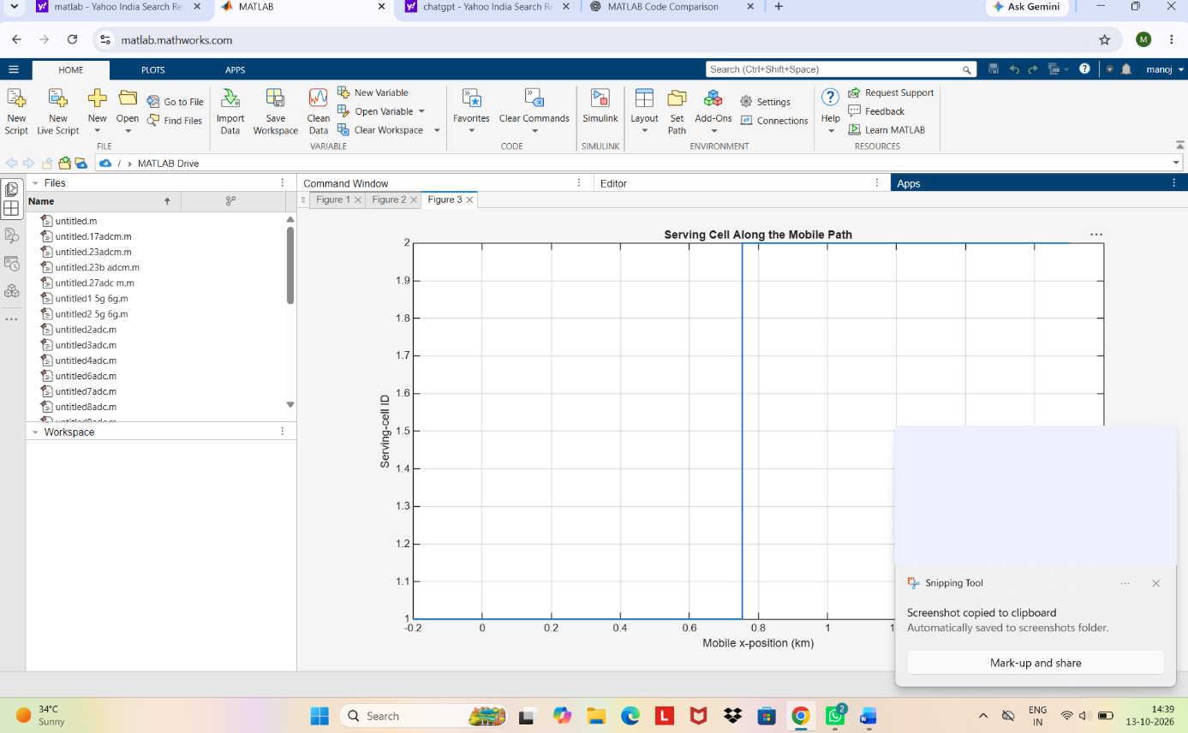
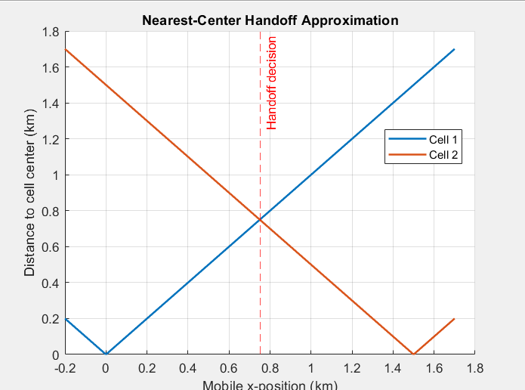
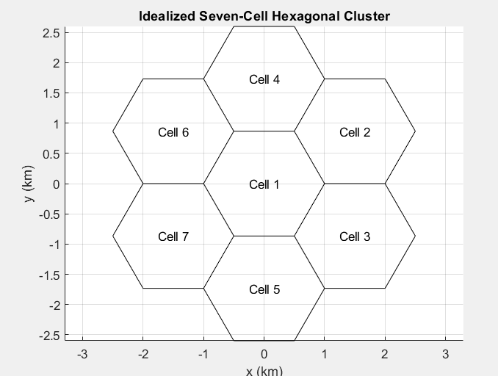
Results to Record
Radius (km) | Cell area (km²) | Estimated cells | Users/cell | Illustrative users
_____1___ | ___2.5981____ | ______2__ | _____30___ | __ 60______
____0.5_ | ___0.64952 | ______8_ | _____30_ | __240_____

Observation | Recorded result
Simulated handoff x-position (km) | _________0.753 km___________________
Effect of halving radius on estimated cells | ____________________________
Effect of changed parameter | ____________________________

Analysis Questions
1. Why does halving the radius increase the idealized number of cells by approximately four for a fixed area?
2. What assumption makes the estimated total user capacity scale directly with the number of cells?
3. At what position does the nearest-center rule switch the serving cell, and why is that point the geometric boundary?
4. Name two radio or network factors absent from this model that could shift or delay a real handoff.
Conclusion
Summarize how cell radius changes the idealized cell count and assumed network capacity, and report the simulated handoff location. State that the model uses ideal hexagons, an area-ratio count, fixed per-cell capacity and nearest-center handoff; it does not model RF propagation, overlap, fading, load or handoff timers.
Assessment Rubric — Experiment 2
Criterion | Weight | 4 — Strong | 3 — Meets | 2 — Partial | 1 — Limited
Hexagonal coverage model | 20 | Correct geometry and clear labeled layout | Mostly correct with minor labeling issue | Some geometry or labels incorrect | Model missing or substantially incorrect
Cell count and capacity comparison | 20 | Correct estimates; assumptions and scaling explained | Minor calculation or explanation gap | Several errors or weak comparison | Estimates missing or unsupported
Handoff simulation | 20 | Correct transition identified and plotted | Transition correct with minor presentation issue | Partial or unclear transition | Handoff absent or incorrect
Parameter study and analysis | 20 | Changes parameters and explains evidence-based effects | Rerun and comparison mostly complete | Limited change or interpretation | No meaningful parameter study
Conclusion and engineering judgment | 15 | Clear conclusion with model limits | Reasonable conclusion, one limit omitted | Mostly repeats outputs | Unsupported conclusion or absent
Report and individual explanation | 5 | Organized evidence; explains code and assumptions | Minor organization or explanation gaps | Evidence or explanation incomplete | Report unclear or unable to explain

